User Assignment Rules

Exercise 1: Investigation

In this exercise, you observe the effect of round robin and user attributes in a group.

1. Log on to ClaimCenter as su. Go to the "Auto1 - TeamC" group.
2. Modify the group so that:

* Thomas Sanders and Faith Thomson have load factors of 100.
* Sylvia Ulveling has a load factor of 50.
* Pam Vance has a load factor of 0.
* Kerrie Winslow has a load factor of 100 but she is a non-member of the group.

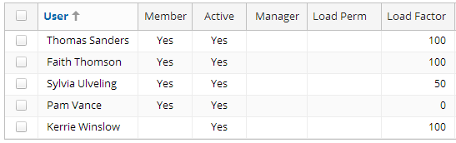

1. Navigate to an auto claim, such as claim **235-53-365871 (Allen Robertson)**. Take note of who currently owns the claim (it is probably Andy Applegate in Auto1 – TeamA). If the claim is not assigned to Andy or someone in Auto1-TeamA, reassign it before beginning your testing. If the claim's loss cause is "Theft of Entire Vehicle," change it to some other loss cause before proceeding to the next step.
2. Reassign the claim 5 times. Each time, assign the claim to the "Auto1 - TeamC" group. Record the user that gets the claim each time.

#1: #4:

#2: #5:

#3:

* 1. Did two of the five assignments go to Thomas Sanders?
  2. Did two of the five assignments go to Faith Thomson?
  3. Did one of the five assignments go to Sylvia Ulveling?
  4. Did any assignment go to Pam Vance or Kerrie Winslow?

1. Reassign the claim to the person and group it was originally assigned to prior to your testing (in #3).

Exercise 2: Configuration

Configure ClaimCenter to meet the following customer requirement from Acme Insurance.

Requirement 1: Assigning FNOL Error Activities to Claim Creator

Recall that when a claim is first created, an "FNOL snapshot" of the claim is taken. This is a read-only record of the information gathered at the time the claim was created. This is useful when important information about the loss changes during adjudication. (For example, a change of loss cause from "collision while turning left" to "collision with auto" might indicate that the insured is trying to hide the fact that he or she is at fault.)

Sometimes, information in an FNOL snapshot varies from later information because of human error. When the insured reports that information in the FNOL snapshot was entered inaccurately, Acme Insurance wants the adjuster to create a "Verify entry of erroneous FNOL information" activity. This activity should be assigned to the person who created the claim.

1. As su, create an activity pattern that meets the following criteria:

* The subject is "Verify FNOL entry error".
* The activity category is "Request"
* The code is "fnol_error_Ext".
* The calendar importance needs to be set because it is a required field.

*Activity Patterns are found in Administration > Business Settings > Activity Patterns (menu link)*

1. Create an activity assignment rule that assigns any activity based on the "fnol_error_Ext" pattern to the person who created the claim. (Use the Claim.CreateUser field. You can assume that the user who created the claim is in the group to which the claim is currently assigned.) If the claim does not have a CreateUser (which can occur with imported claims), then assign the activity to the supervisor of the group which currently owns the claim.
2. The ClaimCenter implementation team has provided the following information:

* In the Acme Insurance Global Activity Assignment rule set, the last rule is a default rule which is always true that assigns activities to the issue owner. Consequently, every activity which exits the Global Activity Assignment rule set has been assigned to a group and a user.

Test Case 1

When you have completed your configuration, run the following test cases:

1. Remember to reload changed classes to test your changes. You may also right-click on the rule set category and compile it. A server restart is not necessary.  
   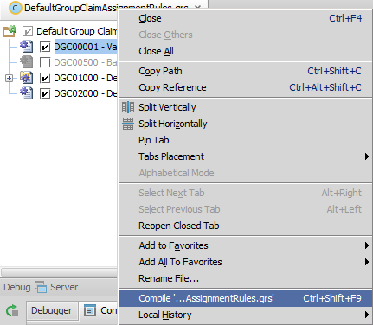
2. Log on as Andy Applegate. Using the quick claim wizard, create an auto claim. Assign the claim to Dan Henson.
3. Create a “Request” activity on the claim using the "Verify FNOL entry error" pattern. Verify that the activity has been assigned to Andy Applegate.

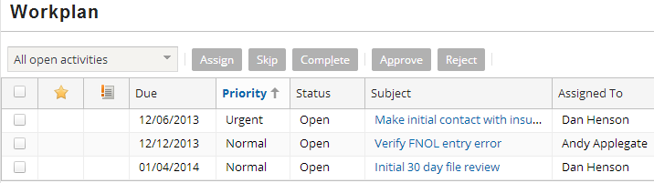

**Requirement 2: Assigning Vandalism Claims Manually**

At Acme Insurance, the adjuster who can best handle a vandalism claim depends on a number of complex factors, such as the type of damage that was done, the state of the vehicle, the police department involved, and so on. Furthermore, the strategy for vandalism assignment changes somewhat over time.

Acme Insurance has therefore decided to manually assign all auto claims whose loss cause is "Malicious mischief and vandalism".

11. Create a claim assignment rule that assigns any claim with an assigned group and a loss cause of "Malicious mischief and vandalism" to the supervisor of that group for manual "pending assignment".

**Test Case 2**

When you have completed your configuration, run the following test cases:

12. As Andy Applegate, navigate to a claim and change its loss cause to "Malicious mischief and vandalism". Reassign the claim and verify that the primary adjuster is now “pending assignment”:



**(Bonus) Requirement 3: Assigning Activities to a Group’s Queue**

**Complete this requirement only if your instructor tells you to do so.**  
(This requirement depends upon the users and groups created in the "Users and Groups" lab, and the enhancement created in the “Introduction to Assignment Rules: Group Assignment” lab.)

At Acme Insurance, whenever an auto claim for a partial theft is filed, a copy of the police (metro) report must be acquired. This work is typically done by a customer service representative, and it can be done by any customer service representative.

13. Create an activity assignment rule that assigns any "get police report" activity for claims assigned to the "Simple Thefts - West" group to that group's Theft Statements queue.

**Test Case 3**

When you have completed your configuration, run the following test cases:

14. As Andy Applegate, navigate to a claim and **manually reassign** the claim to the Simple Thefts - West group. Then, create a "get police report" request activity.

15. Log on to ClaimCenter as testuser5 (Erma TestUser). Verify that the activity is in the Theft Statements queue.

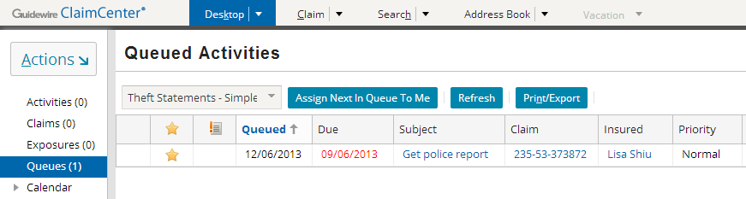

Take ownership of the activity and complete it.  
  
